Capacitors (and inductors) have the ability to store electrical energy, inductors store energy as a magnetic field around the component, but the capacitor stores electrical energy directly, as an ELECTROSTATIC FIELD created between two metal "plates".
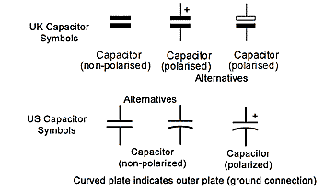

Fig 2.1.1 Basic Circuit Symbols for Capacitors
Fig 2.1.1 shows the UK and US circuit symbols for a variety of capacitor types. A basic fixed value type of capacitor consists of two plates made from metallic foil, that are separated by an insulator. This may be made from a choice of different insulating materials, having good DIELECTRIC properties. Some basic types of capacitor construction are shown in fig 2.1.2a.

Capacitors Have Many Uses.
Capacitors have many uses in electronic circuits. Each purpose uses one or more of the features described in this module. Fig 2.1.2 shows a variety of capacitors. Typical uses would include:
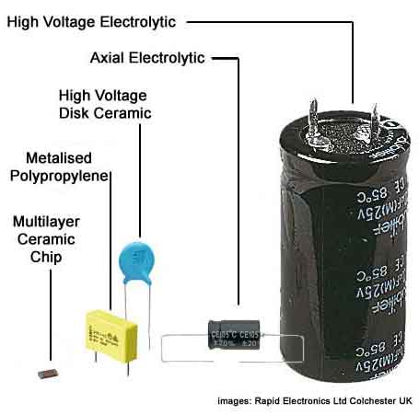
- High Voltage Electrolytic used in power supplies.
- Axial Electrolytic; lower voltage smaller size for general purpose where large capacitance values are needed.
- High Voltage disk ceramic; small size and capacitance value, excellent tolerance characteristics.
- Metalised Polypropylene; small size for values up to around 2µF good reliability.
- Sub−miniature Multi layer ceramic chip (surface mount) capacitor. relatively high capacitance for size achieved by multiple layers. Effectively several capacitors in parallel.

Fig 2.1.2
Top of Page.>

Fig. 2.1.2a Construction − Fixed Value Capacitors
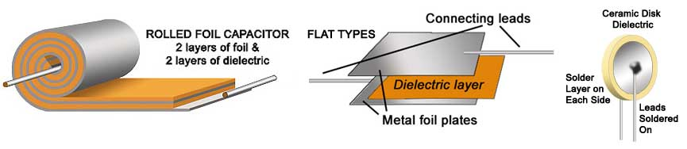
The construction of non−polarized capacitors follows the same pattern over many types. Variations consist of the area of the plates and type of dielectric material used for a given capacitance; ideally the dielectric will be the thinnest material, with the best permitivity, that will also withstand the voltage required. Each of the basic types shown in Fig 2.1.2a will be coated with an insulating layer (often an epoxy resin).

Electrolytic Capacitors
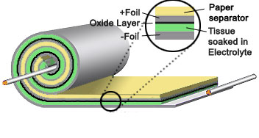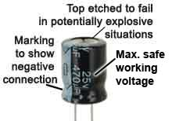
The construction of electrolytic capacitors is similar in some ways to a rolled foil capacitor. Except that the layers between the foil are now two very thin layers of paper, one that forms an insulator separating the rolled pairs of layers and the other, a layer of tissue between the foil plates, soaked in an electrolyte that makes the tissue conductive!
It would seem from the previous paragraph that the soaked tissue places a short circuit between the plates. But the real dielectric layer is created after construction is complete, in a process called "Forming". A current is passed through the capacitor, and the action of the electrolyte causes a very thin layer of aluminium oxide to build up on the positive plate. It is this layer that is used as the insulating dielectric. The capacitor therefore has a very thin and efficient dielectric, giving capacitance values many hundreds times greater than is possible with a conventional plastic film capacitor of a similar physical size.
The down side with this process is that the capacitor is polarised and must not have reversed polarity voltages applied. If this occurs the insulating oxide layer is stripped away again and the capacitor may pass a large current. As this occurs in a sealed container, the "liquid" electrolyte quickly boils and expands rapidly. This can lead to an explosion within seconds! NEVER connect an electrolytic capacitor the wrong way round!
All capacitors, whatever their type also have a maximum safe working voltage (Vwkg). If this voltage is exceeded there is a high risk that the dielectric layer separating the positive an negative plates will break down and cause a short circuit between the plates, this can also cause rapid and extreme overheating resulting in a possible explosion.

Top of Page.>

Fig 2.1.3 Ganged Variable capacitors.

Variable capacitors
The variable capacitors shown in fig. 2.1.3 are used as tuning capacitors in AM radios, although they have largely been replaced by "Varicap" (variable capacitance) diodes, but they can still be found in circuit diagrams and supplier´s catalogues for replacement purposes.
Tuning capacitors have very small values of typically a few pF to a few tens of pF. Large air dielectric types like the animated one on the left have been superceded by miniature types as shown top−right (front and back to show the tiny trimmer capacitors accessed through holes in the rear of the case).

Trimmer capacitors
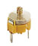
Small trimmer capacitors, adjustable with special trimming tools (DON´T use a screwdriver!) by technicians rather than the equipment user are available in a variety of very small designs. They work in a similar way to the larger variables, with tiny rotating plates and typically PVC film dielectric layers between. Their capacitance is only a few pico farads and they are often used in conjunction with larger variable capacitors (and even fitted inside the case of tuning capacitors) to improve accuracy.

Fig 2.1.4 Variable and Preset Capacitor Symbols
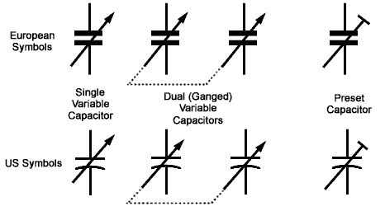
Symbols for variable capacitors are given in fig 2.1.4. Variable capacitors are often available as GANGED components. Usually two variable capacitors are adjusted by a single control spindle. The arrow symbol indicates a variable capacitor (adjustable by the equipment user, and the T shaped diagonal indicates a preset capacitor, for technician adjustment only. The dotted line connecting a pair of capacitors i

