Communication between PC and Mobile using MQTT Protocol Via HiveMQ Broker
In the previous tutorial, it was learnt that how a smart phone and a PC can be set up as MQTT clients and their connection with an MQTT broker can be established. The smart phone was configured as an MQTT client using an android MQTT app - IOT MQTT Dashboard while the PC was configured as MQTT client using a chrome add-on - MQTTLens.
Now, in this tutorial, these MQTT clients - Mobile and PC will be made to communicate with each other using MQTT protocol. The communication between the MQTT clients is only possible via MQTT broker. An MQTT client can be set as publisher, subscriber or both. The publisher MQTT client sends data and information in the form of messages on defined topics to the MQTT broker. The MQTT subscriber can subscribe to defined topics and request data on those topics from the MQTT broker. When a client is configured as both publisher and subscriber, it receives messages on subscribed topics while can also publish messages on defined topics. In this tutorial, both clients (PC and Mobile) will be configured as both subscriber as well as publisher.
Creating Topics on Publish Side of Mobile Client -
After configuring Mobile as MQTT client, the Mobile client is connected to the broker. Now, for publishing a message with the mobile, it is necessary to create a topic and register that topic to the MQTT broker. After creating a topic, the mobile client can send messages on that topic any time whenever required.
After creating a connection (from the previous tutorial), the created connection will display on the MQTT dashboard. Tap on the connection to open connection specific activity.
In the new activity, there are two tabs - Subscribe and Publish. Select the publish tab and tap the 'Plus' button on the top corner of the activity. A pop up will appear asking to select a component type.
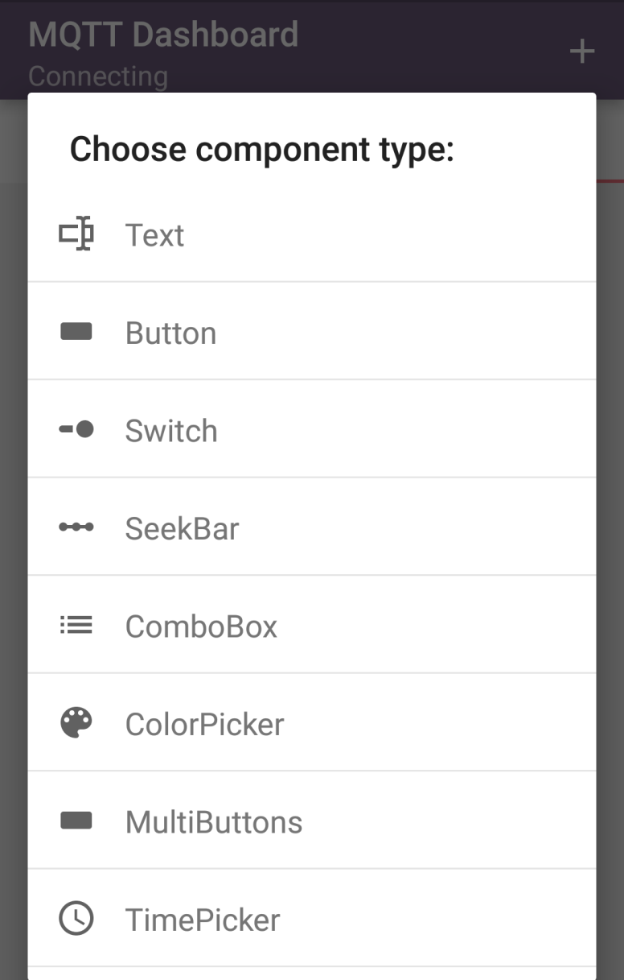
Select text and a Publication activity will open. In this activity, write a friendly name for the client and write the topic name. The friendly name can be anything like Mobile-01. It is not mandatory that it be unique.
The topic name can be maximum 65535 bytes long. It should be an UTF-8 string. The topic can consist of one or more levels. In the topic name, each level is separated by the forward slash. The forward slash acts as topic level separator. Though, it is not necessary to create topics before publishing or subscribing, it is a good practice to do so in advance. An MQTT client can also create topics while publishing or subscribing messages. Any topic must have at least one character. It can be even a forward slash alone.
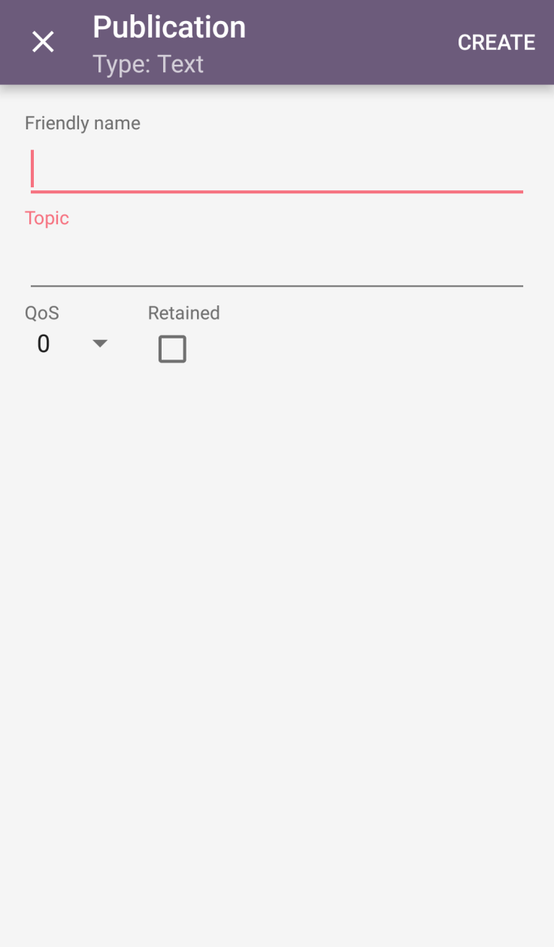
So, create a topic like Mobile/Accelerometer/X/Axis. Next, to register the topic with the MQTT broker, it is important to set Quality of service level (Abbreviated as QoS). The QoS level defines the agreement between sender and receiver of a message regarding the guarantees of delivering a message. There are three QoS level (0, 1, and 2).
QoS-0 - The message on the topic will be delivered at most once. There can be possible of losing the message.
QoS-1 - The message will be delivered at least once. There can be chance of duplication of message.
QoS-2 - The message will be delivered exactly once.
Set the QoS level to 1 for publishing the messages. There is an option of retained flag. If it is checked, it is set to 1 and if left unchecked, it is set to 0. Set the retain flag to 0. If retain flag is set to 1 then the broker will hold on to the message after it has been delivered to the subscriber. So, if there will be now subscription on the topic, the last retained message will be delivered to the subscriber.
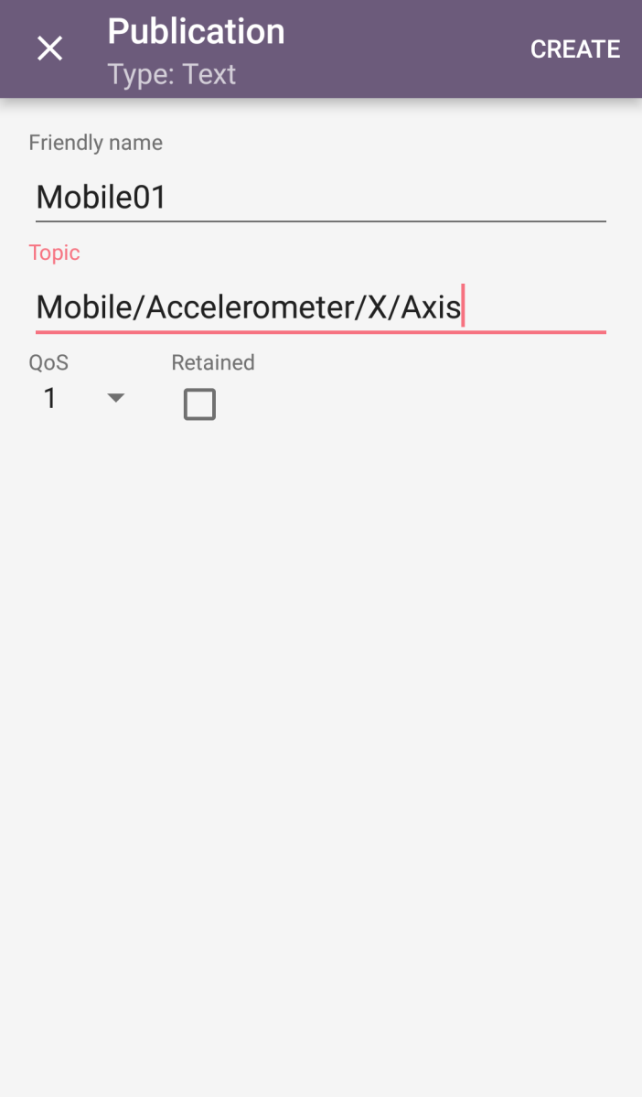
Tap the create button on the top corner of the activity. Now, the mobile client is ready to publish messages on the defined topic.

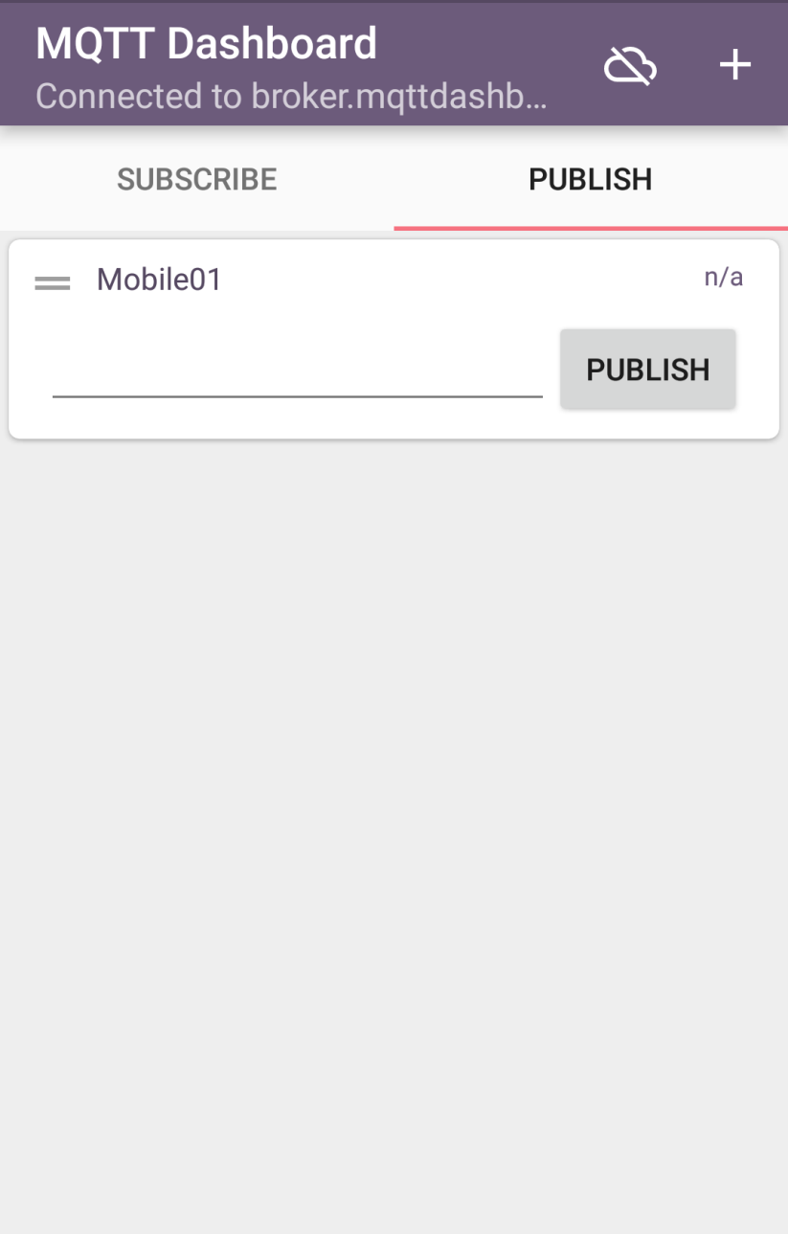
Creating Topics on Subscribe Side of Mobile Client -
Simultaneously, the topic on subscription side can also be set. The client subscribes the topic from MQTT broker. The Topic is the path to which other client is publishing the message. The subscriber client will register the topic on the broker. If the broker will have messages on that topic from the publisher client, the broker will transmits all those messages to the subscriber.
Tap on the connection to open connection specific activity and select the subscribe tab. Tap the 'Plus' button on the top corner of the activity. A Subscription activity will open.
In this activity, write a friendly name for the client and write the topic name. The friendly name can be anything like Mobile-01. It is not mandatory that it be unique.
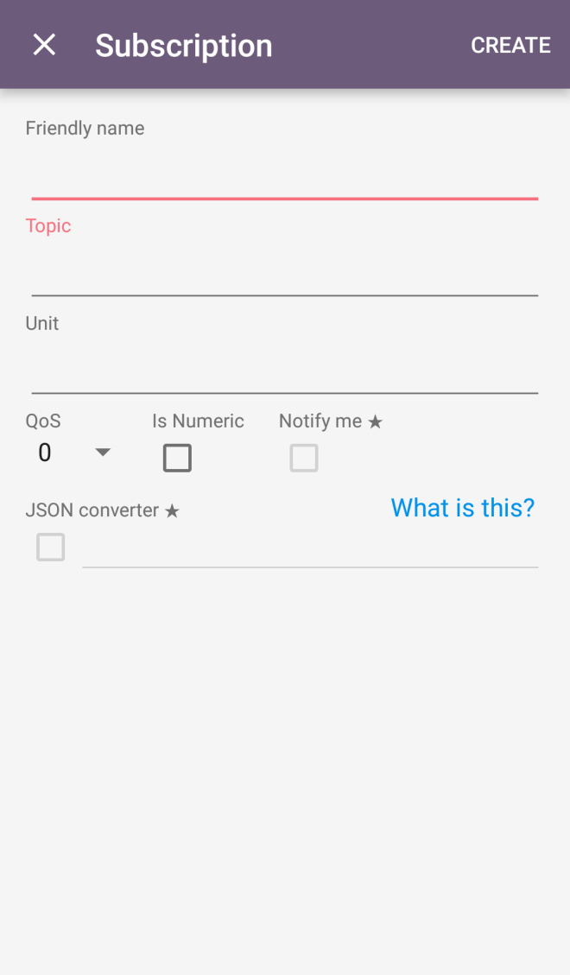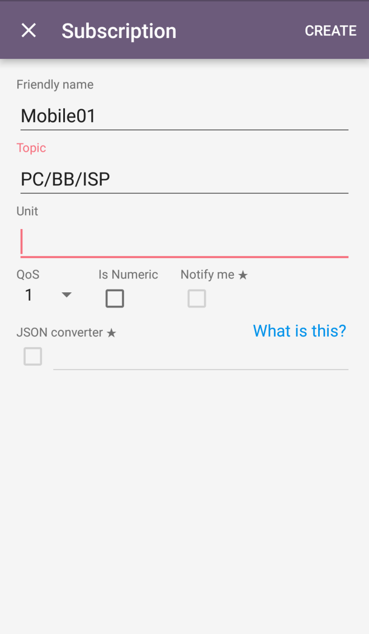
The MQTT protocol allows use of wildcards in topic names in subscription but not in publication. If a '+' symbol is used as a topic level, it acts as single level wildcard. Suppose, if the topic name is Mobile/Accelerometer/+/Axis, then this will match to the following -
Mobile/Accelerometer/X/Axis
Mobile/Accelerometer/Y/Axis
Mobile/Accelerometer/Z/Axis
but not to these -
Mobile/Accelerometer/X/Change
Mobile/Accelerometer/Y/Change
Mobile/Brightness
If a '#' symbol is used as a topic level, it acts as multiple level wildcard. Suppose, if the topic name is Mobile/Accelerometer/#, then this will match to the following -
Mobile/Accelerometer/X/Axis
Mobile/Accelerometer/Y/Axis
Mobile/Accelerometer/Z/Axis
Mobile/Accelerometer/X/Change
Mobile/Accelerometer/Y/Change
but not to these -
Mobile/Temperature/Celsius
Mobile/CPU/Speed
The topic names starting with '$' symbol are reserved for internal statistics of the MQTT Broker. A client cannot publish messages to such topics.
Write a topic name like PC/BB/ISP and leave the unit filed. Set QoS level to 1 and keep is-numeric checkbox unchecked. Check the Notify Me checkbox so that whenever a message is received at broker for the subscribed topic, a notification will be generated by the app. Any JSON converter is not used so, keep the JSON converter option also unchecked. JSONPath expressions refer to JSON structures in context to XML documents. The topic name is prefixed with '$' on checking this option making the topic reserved. Tap the create button. The subscribed topic will now display on the connection activity under subscribe tab.
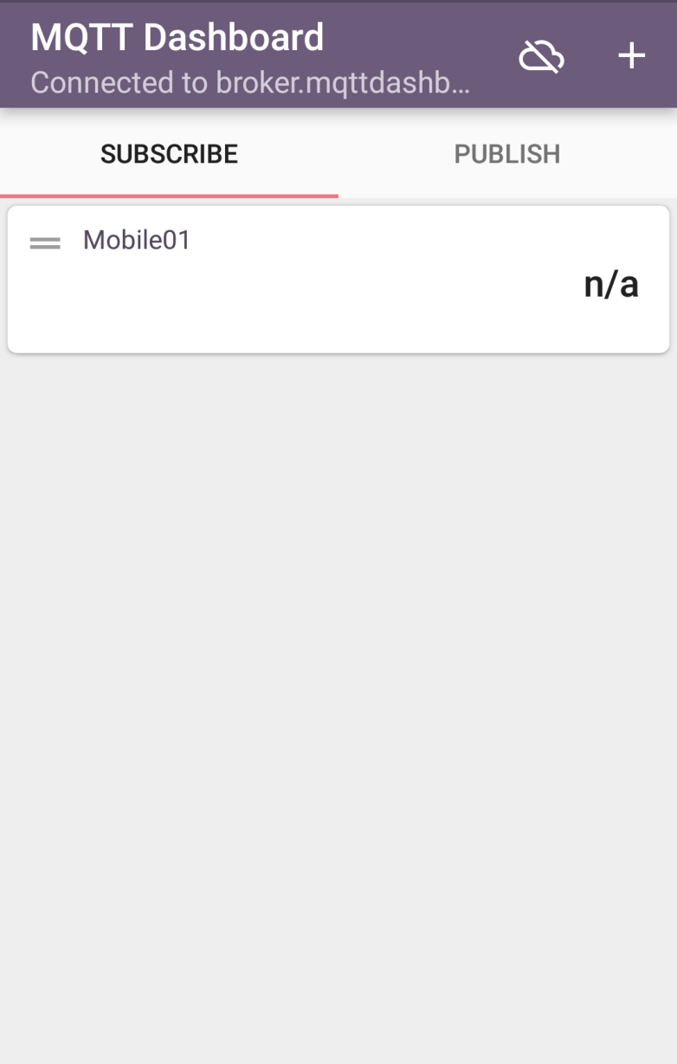
Creating Topics on Publish Side of PC Client -
After configuring PC as a client, PC client is connected to the MQTT broker. For publishing message, It is important to create a topic. Launch the MQTTLens add-on and create connection as described in the previous tutorial. Scroll down to Publish option.
Write the topic name - 'PC/BB/ISP' and set the QoS level to 1. Keep the retained option unchecked.
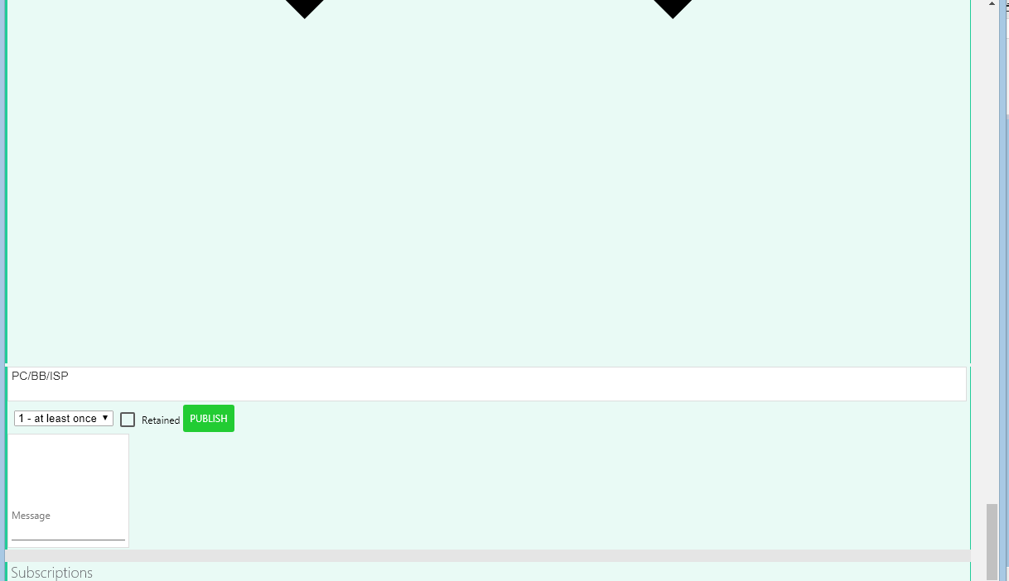
Now, the PC client registers the topic to the MQTT broker and can send the message to the broker. Write a message like the topic PC/BB/ISP can have a message - Tikona and click on the Publish button.
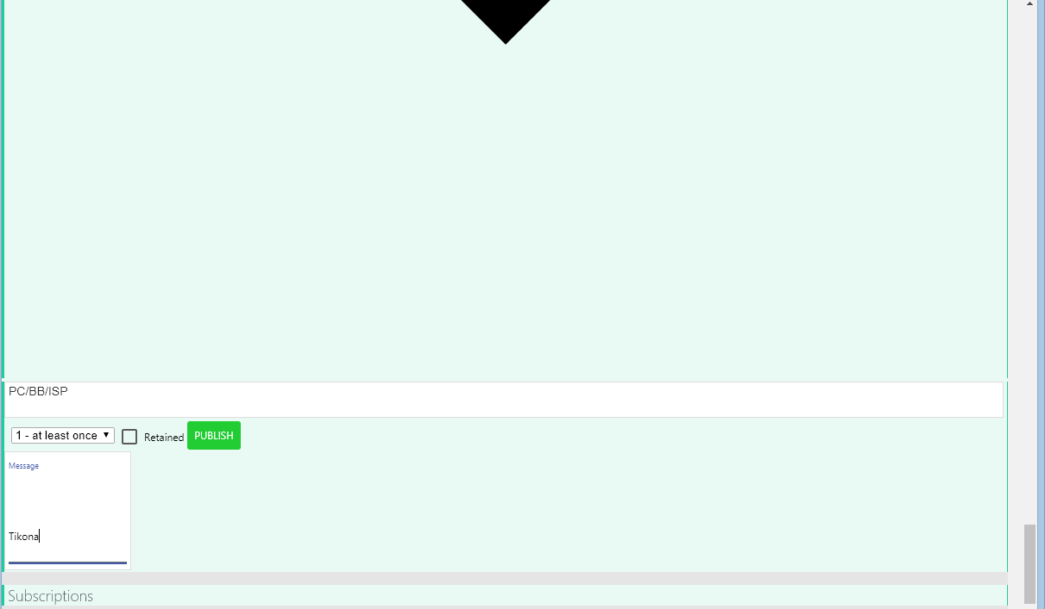
On clicking the publish button the message will be sent to the mobile client.
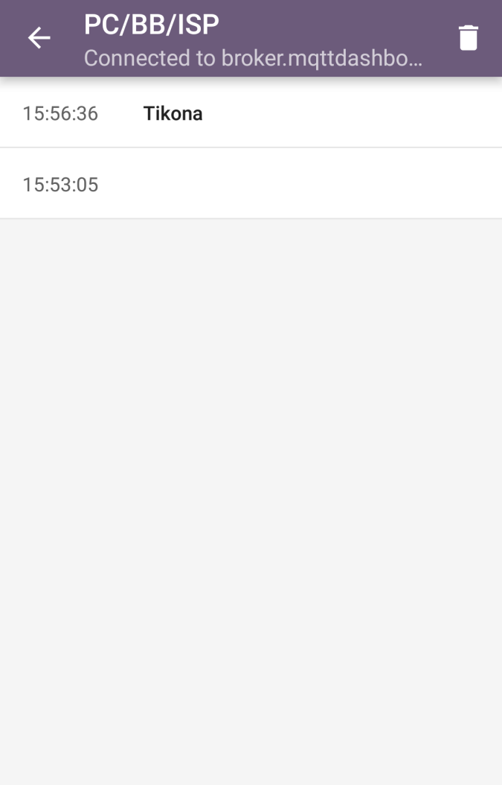
It can be observed that the MQTTLens assign a random Client ID to the PC. The messages received from the PC Client are visible on the Mobile Client with time stamp.

Creating Topics on Subscribe Side of PC Client -
The PC Client can subscribe to the topic published by the Mobile Client. Scroll down to subscribe option.
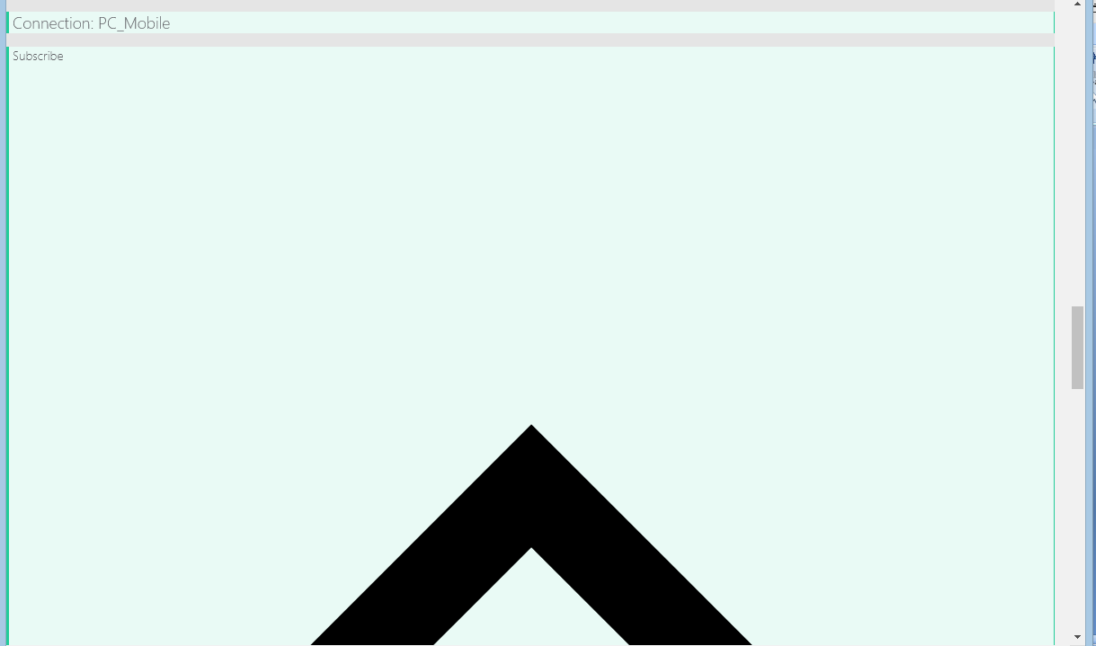
Write the topic name - 'Mobile/Accelerometer/X/Axis', set the QoS Level to 1 and click subscribe button.
On the Mobile Client, send a message on the topic 'Mobile/Accelerometer/X/Axis' like '14' and click Publish button.

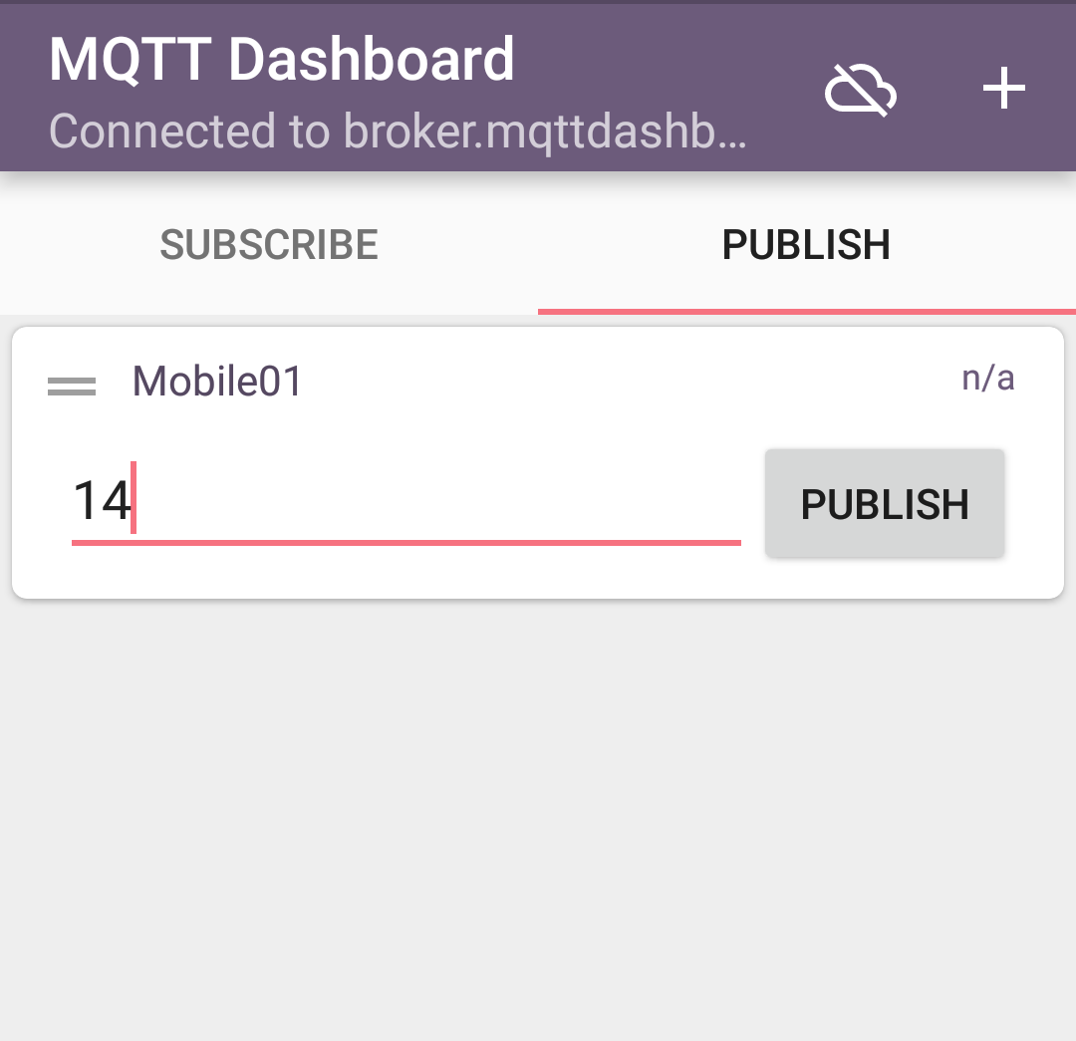
The PC client registers the topic to the MQTT broker and will receive the messages whenever the broker will have. Scroll down the MQTTLens window to check the received messages from the Mobile client.
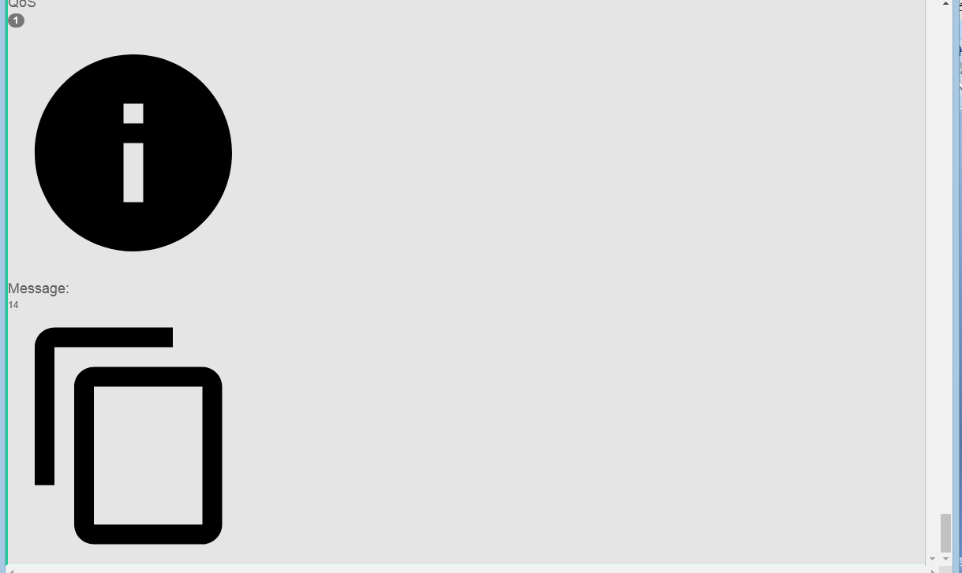
Communication between mobile and PC clients -
The PC client and the Mobile Client have connected to the HiveMQ Broker with the same connection name. The mobile client is set as publisher for topic - 'Mobile/Accelerometer/X/Axis' and set as subscriber for topic - 'PC/BB/ISP'. The PC client is set as publisher for topic - 'PC/BB/ISP' and set as subscriber for topic - 'Mobile/Accelerometer/X/Axis'.
When either client publishes a message as publisher, the message is received on the other client as it has subscribed for that topic.
Mobile client is publishing the message “14” to the MQTT broker. The MQTT broker is passing the message to the PC client as PC client has subscribed the same topic. The PC client is publishing the message “Tikona” on the topic “PC/BB/ISP” to the MQTT broker. The Mobile client has also registered the same topic “PC/BB/ISP” from the MQTT broker. So, the mobile client receives the message automatically whenever PC client publishes the message.
The MQTT broker simply passes the messages to the subscribed clients. The two devices are communicating with each other using publish and subcription model. The communication between the multiple devices can be set up this way provided the connection name and MQTT broker remain the same.
PC to PC Commnication using HiveMQ Broker -
The communication between two PCs or two mobiles can also be setup using the HiveMQ broker. For connecting two PCs, the MQTTLens add-on must be installed on Chrome on both the PCs. They must connect to same MQTT broker which is HiveMQ in this case and should have the same connection name.
Let one of the PC be identified by name PCclient-01. It can register the topic PC01/PC02 with QoS set as 1 on the MQTT broker. The QoS defines the accuracy of data transfer. Let publish a message “Hi! This is client-1” to the MQTT broker.
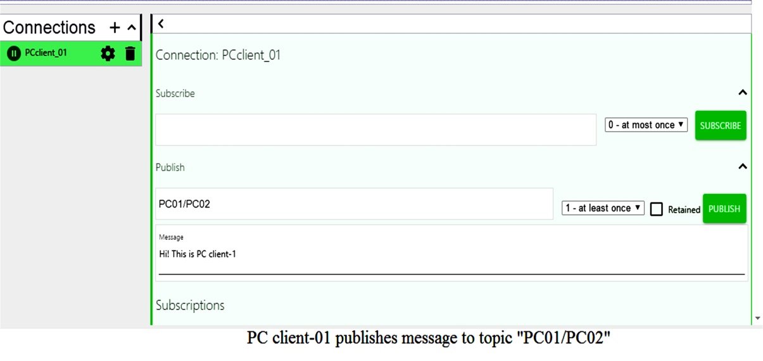
Now let other PC be identified by name PCclient-02 and let it subsribe to the topic “PC01/PC02” with QoS level 2. It will receives the message from broker. Whenever the PCclient-01 publishes the message to the MQTT broker, the PCclient-02 receives the message from the MQTT broker automatically.
In the same way, PCclient-02 can register the topic “PC02/PC01” on MQTT broker with QoS level 1. Let it publish the message “Hi! This is PC client-2” on MQTT broker.
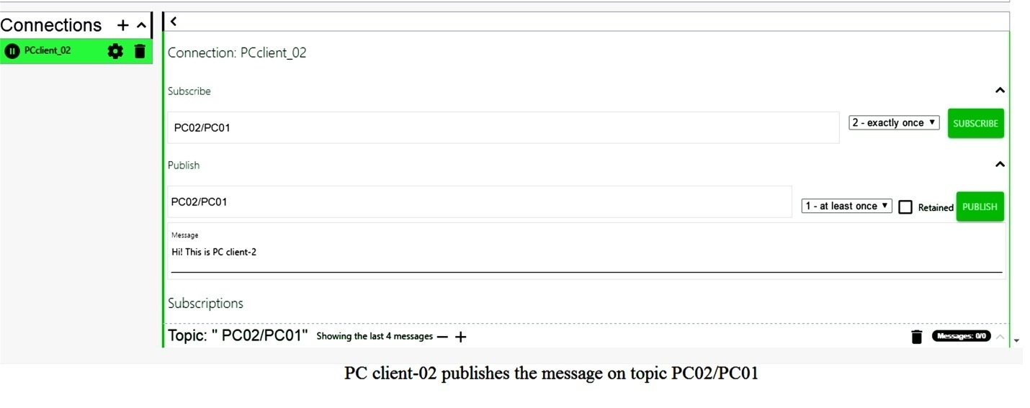
The PCclient-01 has subscribed the same topic with QoS level 1 from MQTT broker and receives a message whenever PCclient-02 publishes the message. In this way, two PC clients communicate with each other through MQTT protocol.
In the next tutorial, mobile to mobile communication using cloudMQTT broker will be demonstrated.
Meta tags and Images
Meta Keywords
Keyword | Competition | Volume
Internet of Things | Medium | 100K-1M
IOT | Medium | 100K-1M
IOT Devices | Medium | 10K-100K
IOT platform | Low | 1K-10K
IOT applications | Low | 1K-10K
MQTT android app, MQTT Chrome plugin, MQTT PC, IOT, Internet of Things, MQTT, Message Queue Telemetry Transport, MQTT brokers, MQTT Client, Making android phone MQTT Client, Making PC MQTT Client, public MQTT brokers, HiveMQ, IOT MQTT Dashboard, MQTTlens

Meta Description
Learn to set a mobile and PC as both MQTT subscriber and MQTT publisher on HiveMQ broker. Learn to create topics and send messages on the defined topics between PC and mobile.

Meta Abstract
Learn to set a mobile and PC as both MQTT subscriber and MQTT publisher on HiveMQ broker. Learn to create topics and send messages on the defined topics between PC and mobile.
File-Name: IOT-MQTT-Dashboard-Connections
Alt: Connections in IOT MQTT Dashboard Main Activity - MQTT Android App
Caption: in IOT MQTT Dashboard Main Activity

File-Name: IOT-MQTT-Dashboard-Publish-Subscribe
Alt: IOT MQTT Dashboard Publish Subscribe Activity - MQTT Android App Guide
Caption: IOT MQTT Dashboard Publish Subscribe Activity
File-Name: IOT-MQTT-Dashboard-Publish-Component
Alt: IOT MQTT Dashboard Publish Component Types
Caption: IOT MQTT Dashboard Publish Component Types
File-Name: IOT-MQTT-Dashboard-Publication-Activity
Alt: IOT MQTT Dashboard Publication Activity
Caption: IOT MQTT Dashboard Publication Activity

File-Name: IOT-MQTT-Dashboard-Publication-Topic
Alt: Topic Creation on IOT MQTT Dashboard Publication Activity
Caption: Topic Creation IOT MQTT Dashboard Publication Activity
File-Name: IOT-MQTT-Dashboard-Publish-Topics
Alt: Publish Topics Listed on IOT MQTT Dashboard Publish Subscribe Activity
Caption: Publish Topics Listed on IOT MQTT Dashboard Publish Subscribe Activity

File-Name: IOT-MQTT-Dashboard-Subscribe-Activity
Alt: IOT MQTT Dashboard Subscribe Activity
Caption: IOT MQTT Dashboard Subscribe Activity

File-Name: IOT-MQTT-Dashboard-Subscribe-Topic
Alt: Topic Creation on IOT MQTT Dashboard Subscribe Activity
Caption: Topic Creation on IOT MQTT Dashboard Subscribe Activity
File-Name: IOT-MQTT-Dashboard-Subscribe-Topics
Alt: Subscribe Topics Listed on IOT MQTT Dashboard Publish Subscribe Activity
Caption: Subscribe Topics Listed on IOT MQTT Dashboard Publish Subscribe Activity

File-Name: MQTTLens-Publish-Window
Alt: MQTTLens Publish Window
Caption: MQTTLens Publish Window
File-Name: MQTTLens-Publish-Window-Topic
Alt: Topic Creation on MQTTLens Publish Window
Caption: Topic Creation on MQTTLens Publish Window
File-Name: MQTTLens-Publish-Window-message-Publishing
Alt: Publishing Message on a Topic on MQTTLens Publish Window
Caption: Publishing Message on a Topic on MQTTLens Publish Window

File-Name: MQTT-Message-on-Mobile-HiveMQ
Alt: MQTT message received on Mobile Client from PC Client via HiveMQ Broker
Caption: MQTT message received on Mobile Client from PC Client via HiveMQ Broker

File-Name: MQTTLens-Subscribe-Window
Alt: MQTTLens Subscribe Window
Caption: MQTTLens Subscribe Window
File-Name: MQTTLens-Subscribe-Window-Topic
Alt: Topic Creation on MQTTLens Subscribe Window
Caption: Topic Creation on MQTTLens Subscribe Window
File-Name: MQTTLens-Subscribe-Window-Topics
Alt: Topic Creation on MQTTLens Subscribe Window
Caption: Topic Creation on MQTTLens Subscribe Window

File-Name: IOT-MQTT-Dashboard-Publishing-message
Alt: Publishing Message on a Topic on IOT MQTT Dashboard
Caption: Publishing Message on a Topic on IOT MQTT Dashboard

File-Name: MQTT-Message-on-PC-HiveMQ
Alt: MQTT message received on PC Client from Mobile Client via HiveMQ Broker
Caption: MQTT message received on PC Client from Mobile Client via HiveMQ Broker

File-Name: PC-to-PC-HiveMQ-01
Alt: PC to PC Message Passing using HiveMQ Broker
Caption: PC to PC Message Passing using HiveMQ Broker
File-Name: PC-to-PC-HiveMQ-02
Alt: PC to PC Message Passing using HiveMQ Broker
Caption: PC to PC Message Passing using HiveMQ Broker
Links
Anchor Text: MQTT clients (Page 1)
Link: How to set up PC and Mobile as MQTT Clients (17th Post in this Series)

Anchor Text: MQTT protocol (Page 1)
Link: Understanding MQTT Protocol (14th Post in this Series)

Anchor Text: MQTT broker (Page 1)
Link: MQTT Brokers (15th Post in this Series)

Anchor Text: mobile to mobile communication using cloudMQTT broker (Page 17)
Link: Next Tutorial in this Series

